**Business Intelligence and Data Visualization Lab Manual**

**CSL 232**

Project Report



Faculty name: Ms. Akanksha Kaushik Student name: Agam Aggarwal

Roll No.: 20CSU203

Semester: Vth

Group: DSA-2

**Department of Computer Science and Engineering**

**The NorthCap University, Gurugram- 122001, India**

**Session 2022-23**

**Topic-** Financial-Consumer Overview

**Project description -**

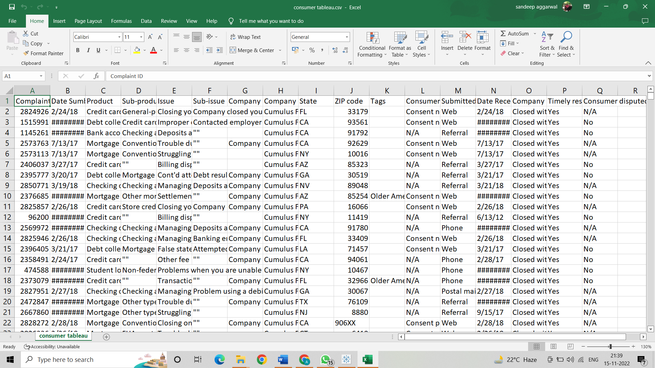

**We have made the project on Financial Consumer Complaints. In this, we used this dataset which was maintained by Mark Bradbourne which is published on data.world website by him.**

**We used this data to find out how many complaints were registered for a particular interval of time, what was the time of response to their complaints, how many of them are in progress, what is the disputed rate, how many were resolved with extra cost or no cost.**

**We also used different visualizations like bar charts, pie charts, Hexmap etc to find out the complaints on the basis of states, issue, media, product and consumer percentage disputed which can be very useful to know the factors which needs the work most.**

**In this dataset fields such as product, sub product, company, state, zip code, consumer satisfaction etc were used all together to form different sheets in tableau.**

**Problem Statement –**

The dataset “Financial Consumer Problems” tells us about the various financial problems faced by consumers in USA. Some common problems are closing your account, managing accounts, trouble during payment processes ang many more.

So our project shows how problems were originated, disputes were solved or not etc.

**Analysis –**

Through this project we could easily analyse the Financial Consumer Disputes.

**System Requirements -**

8 GB RAM (Recommended)

2.60 GHz (Recommended)

**SOFTWARE REQUIREMENTS-**

Tableau Desktop (Professional Edition)

**Output Screenshots –**

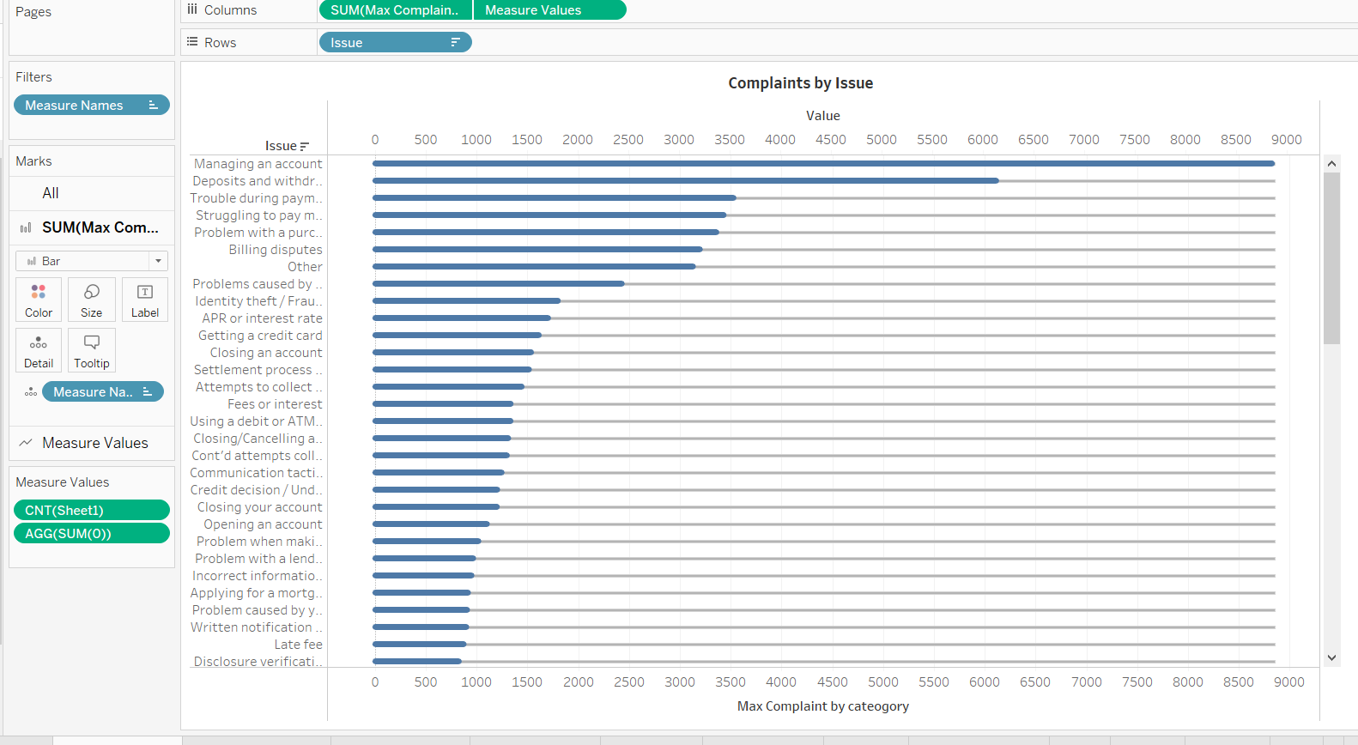

**Complains by Issue**

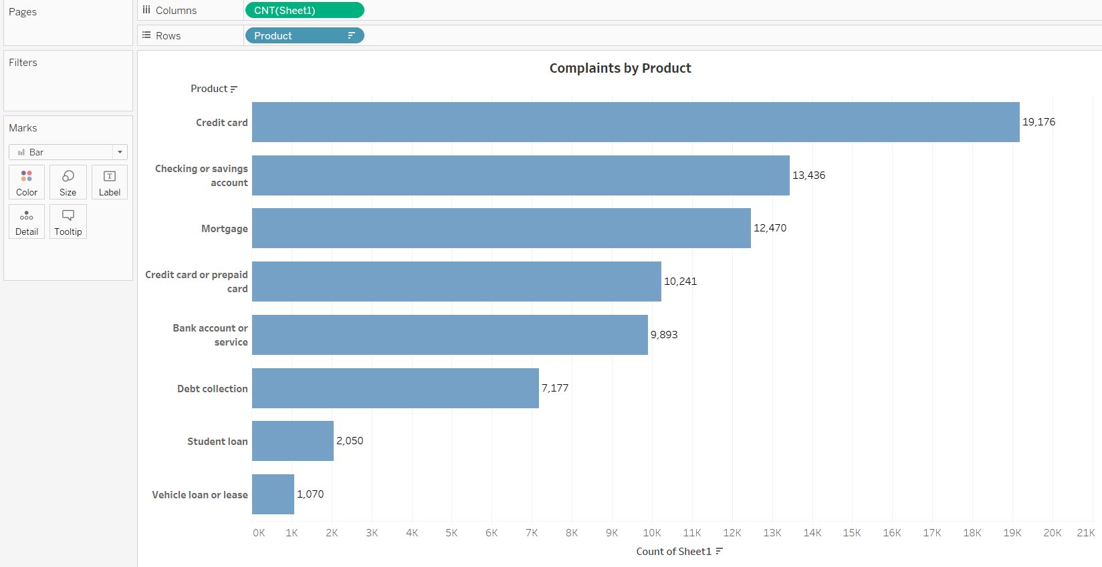

**Complaints by Product**

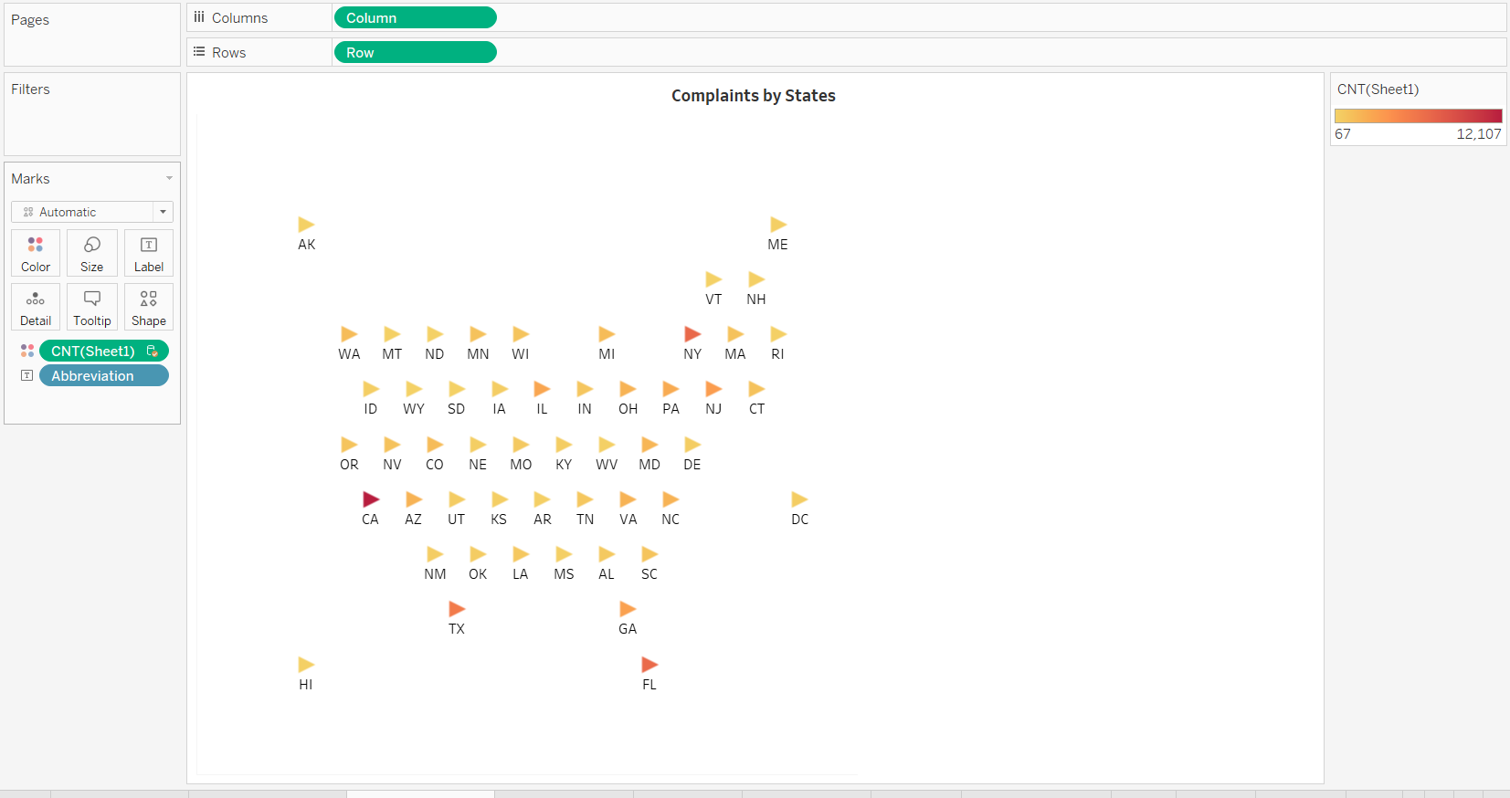

**Complaints by States**

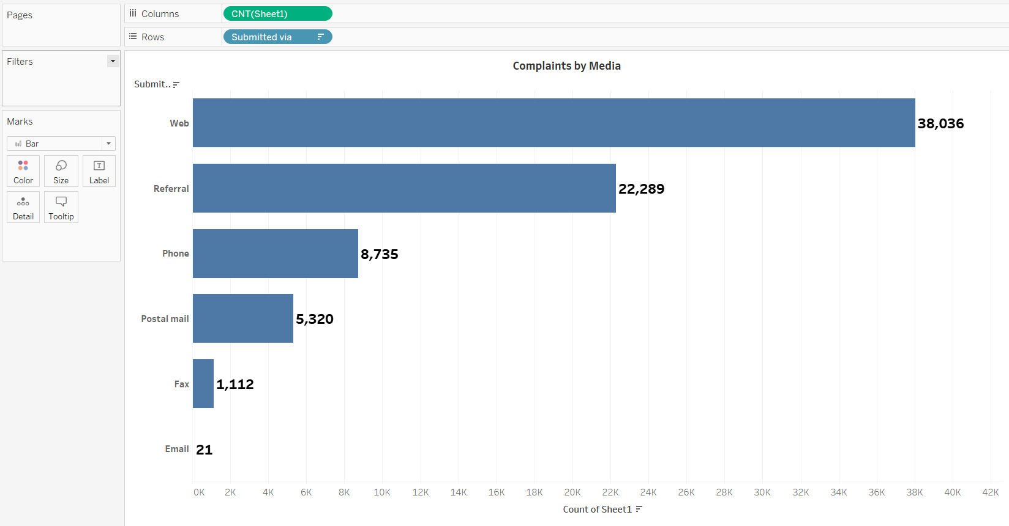

**Complaints by Media**

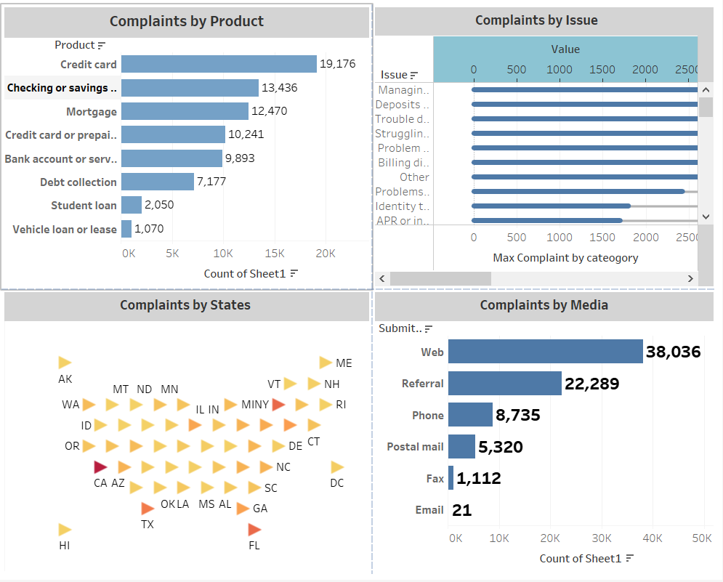

**Single overview of complaints received from various platforms**

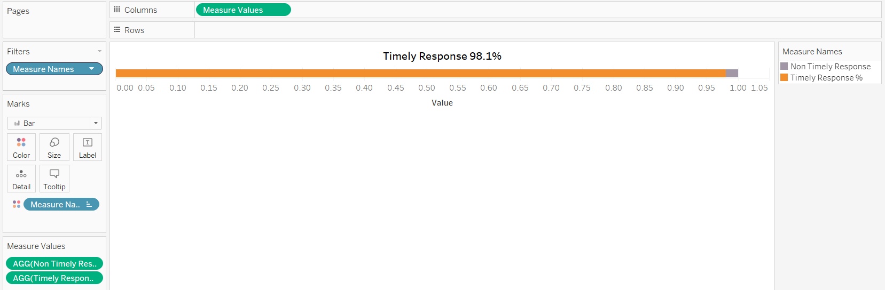

**Timely Response of the Problems**

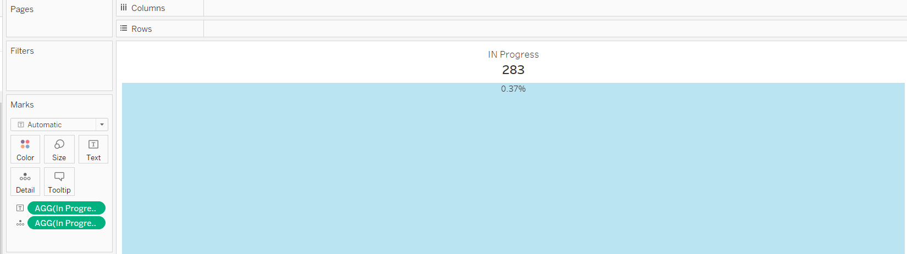

**IN progress problems**

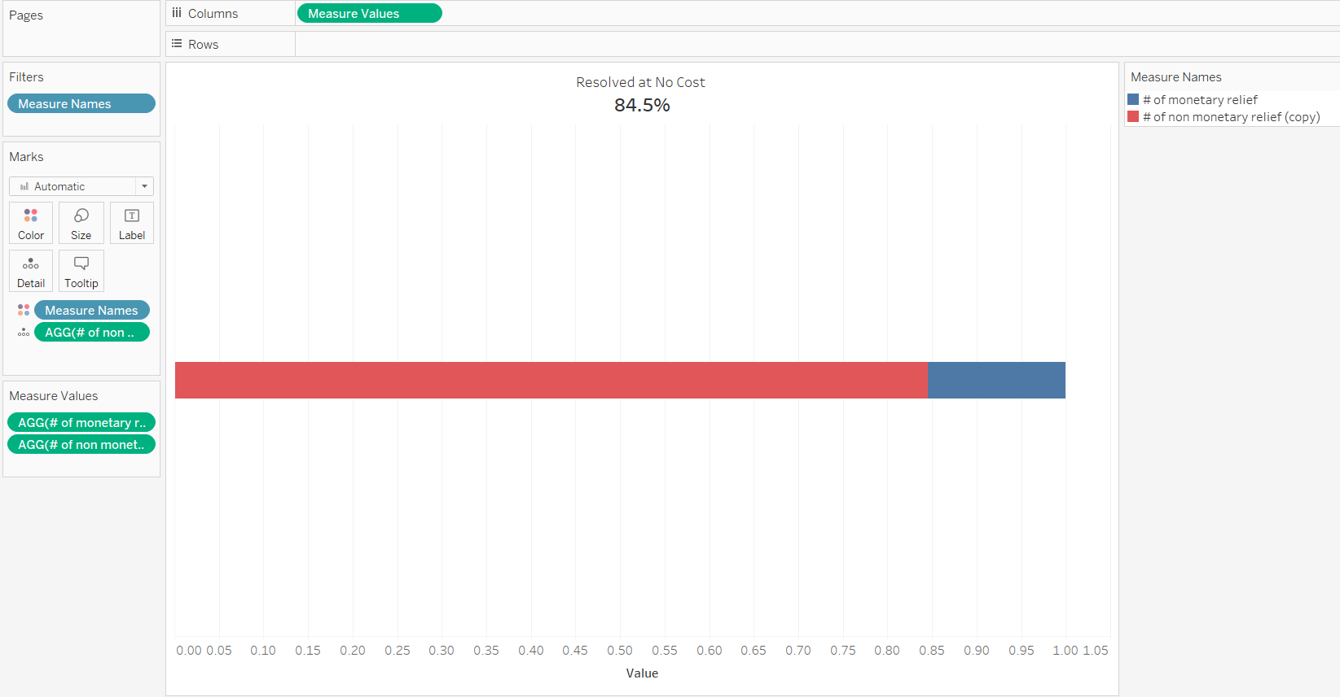

**Problems resolved at No Costs**

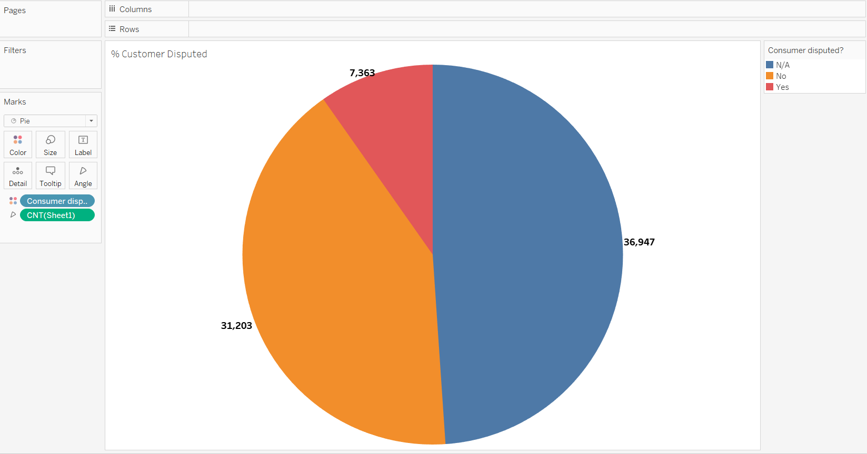

**Consumer Disputed**

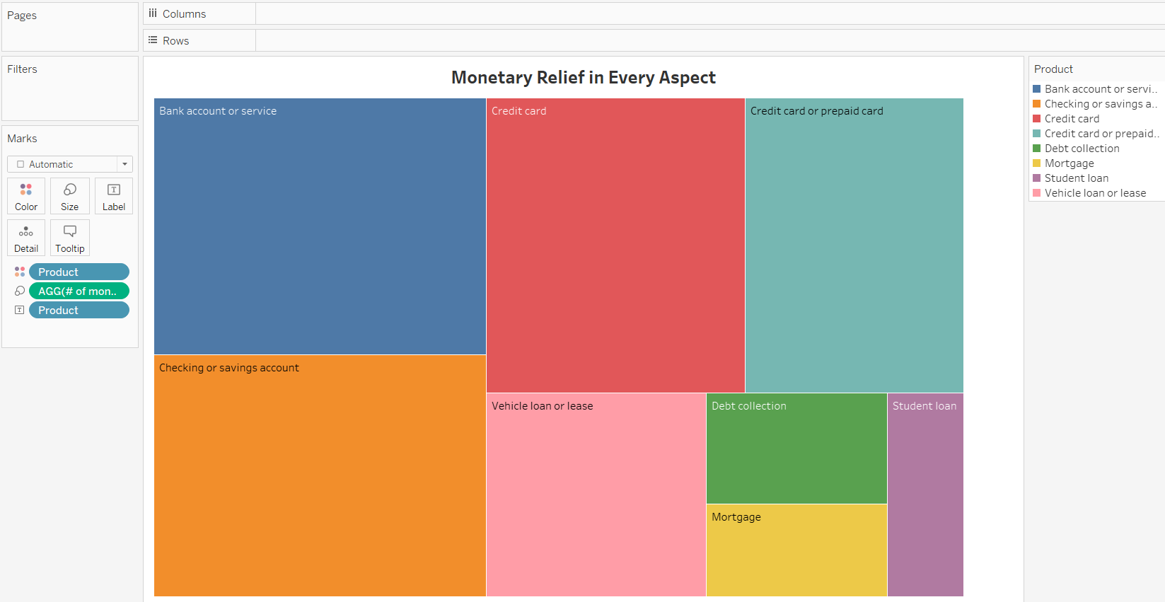

**Common Problems Distribution**

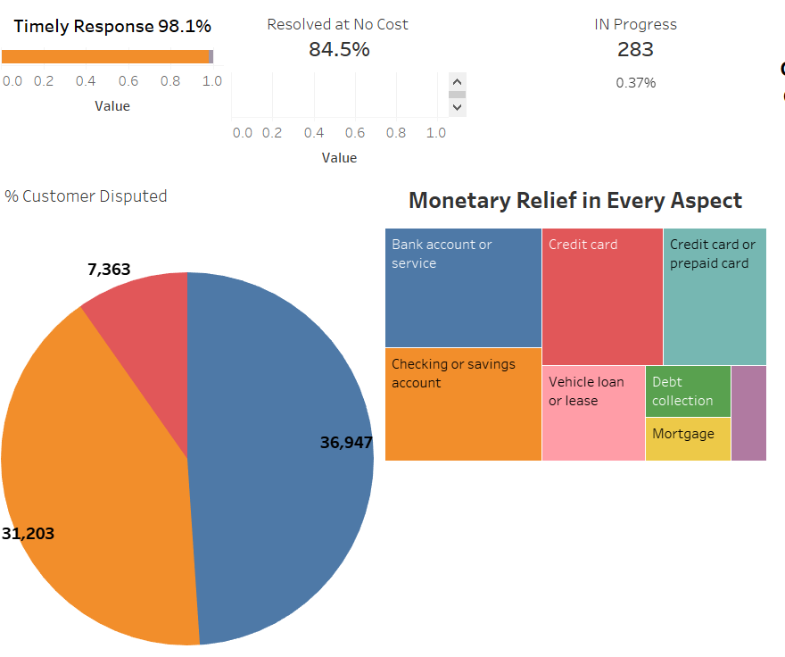

**Overview of above mentioned slides.**

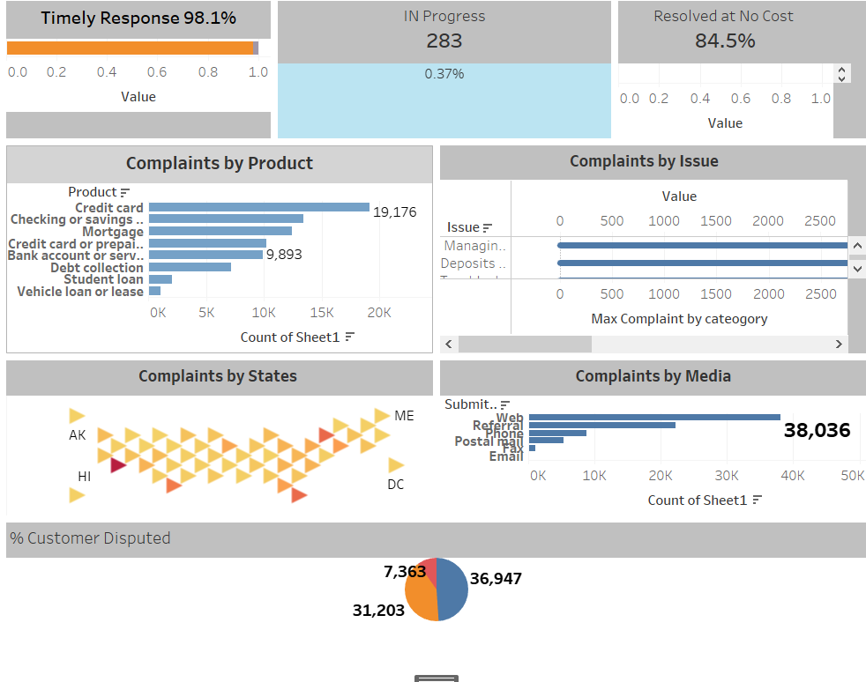

**Final Overview of the project**

**Conclusion and Future Scope –**

Hence to conclude the project deals with the financial problems faced by consumer in The USA. The tableau project gives a better understanding of many aspects vividly with the help of various representation such as bar graph, pie charts, box plots, scatter plot, hexmap and many more.

Future scope is that how the country can use the slides to improve on their financial services and provide a better experience to consumers. Also it might be beneficial for banks, insurance company etc**.**